SOFTWARE ENGINEERING

EXPERIMENT 1 : Create a Kanban Board to Visualize the Tasks in Jira

AIM
To create a Kanban Board in Jira with To Do, In Progress, and Done columns, add at least five sample tasks, and move the tasks across the columns to simulate the workflow of a project.

PROCEDURE

1.Click Projects and select Create Project.
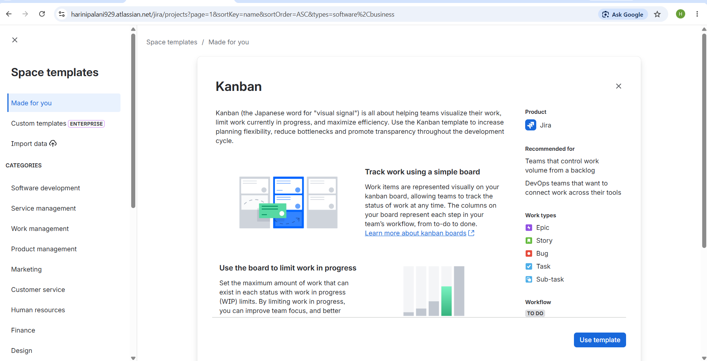
2.Choose the Kanban project template and create a new project by entering the project name and project key.
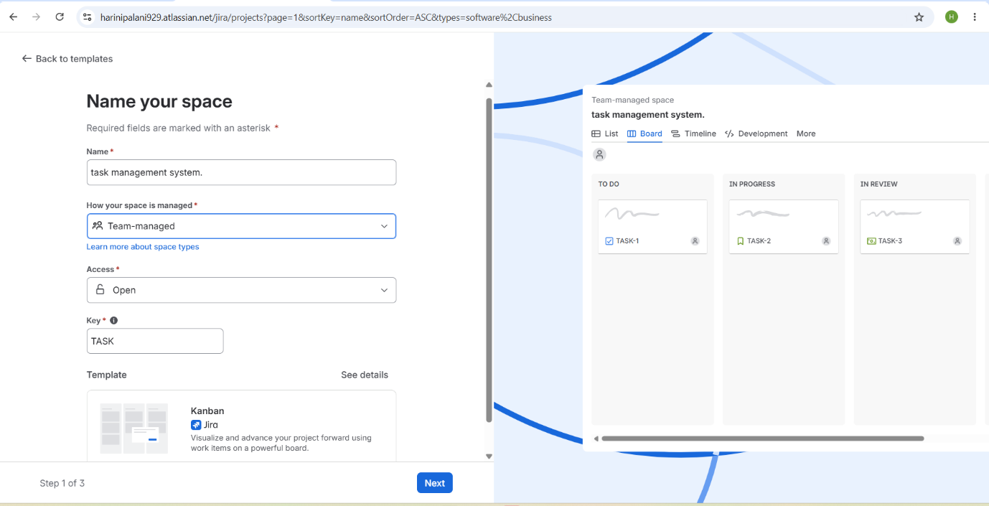
- Open the Kanban board, which contains the default columns: To Do, In Progress, and Done.
- Click Create and add at least five sample tasks
- Verify that all the created tasks are displayed under the To Do column.
- Drag one or more tasks from the To Do column to the In Progress column to indicate that work has started.
- After completing the tasks, drag them from the In Progress column to the Done column.
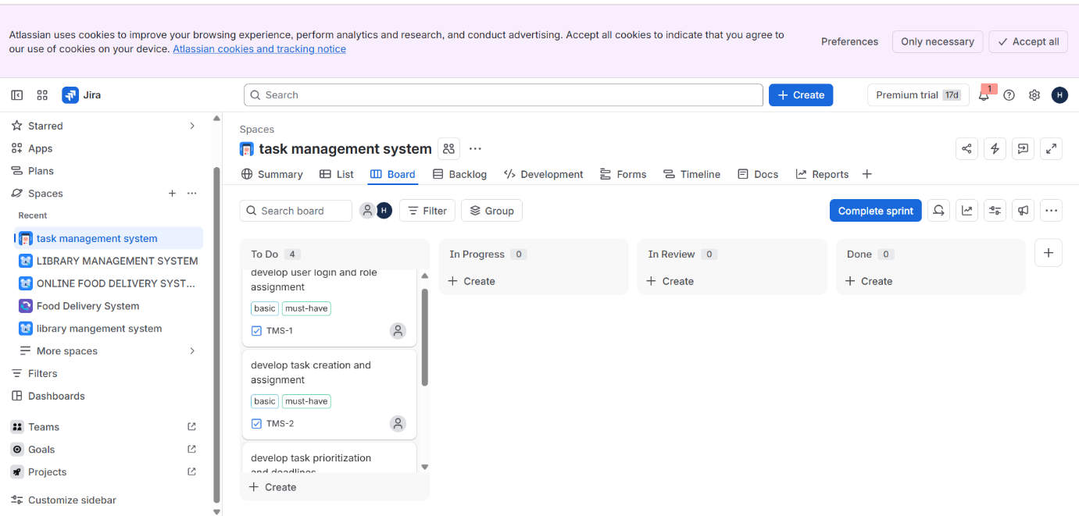
- Continue moving the remaining tasks through the workflow until all tasks have been completed.
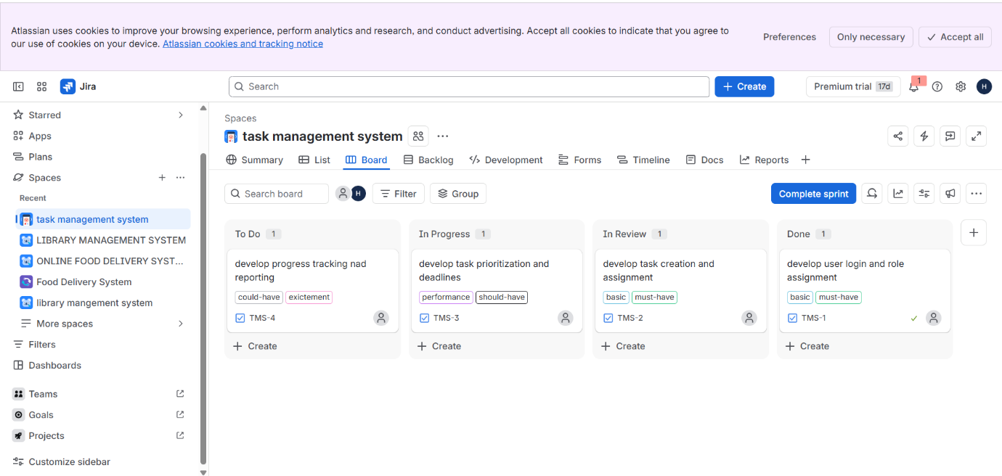
- Verify that the Kanban Board correctly displays the status of each task and take screenshots of the workflow for submission.
